**PRODUCT REQUIREMENTS**

**Project: Accessible Amusement Park Website**

**Team:**

**Revision History**

|  |  |  |
| --- | --- | --- |
| **Date** | **Description** | **Author** |
| 10/09/2024 | Software Requirement |  |

**Brief Problem Statement**

Our team is funded to develop a way to help guests of an amusement park, especially those with disabilities, to be able to access the necessary resources in the park and effectively plan for their day. We engaged stakeholders and potential users and asked them what they would like the new platform to provide. It was, therefore, possible to achieve the following objectives.

-The amusements and park services should have specific descriptions of the contents and services for the rental of the amusement park rides.

-Ensure that website navigation is accessible enough for persons using screen readers and keyboard users.

* Communicate to the guests about the park's freedom and when they will likely wait for a ride.
* Ensure to provide information regarding the reception of people with disability and the accessibility of services to such persons.
* To make it possible, the visit to the specialized park should be subjected to a time management plan.
* People from different backgrounds must be integrated and embraced within the system while user interfaces must be created.

This will be done by developing a web application where clients can view the current information concerning the facilities, book and utilize many concessions. It will also allow the User to input his/her preferences, get updated and even liaise with the park officials. To summarize, this will ensure that anyone visiting this platform can experience the best and quickly get any information they need, regardless of the disability level.

**Stakeholders**

**Amusement Park Management - Investor and Board of Directors:**

This project is being financed and implemented by the amusement park management, and thus, they require authorization for this purpose and funding for this accessible platform. The management team will, therefore, be engaged from the conceptualization phase of the project life cycle. There will be weekly presentations and meetings with the management and the board of directors to make them fully engaged. It will also enable additional resources as their participation needs arise.

**Amusement Park Marketing Team - Product Owner:**

The marketing department in the amusement park is the product owner. They are supposed to define what goals they want to see on the platform and explain it to the developers. The responsibilities of the product owner include: The responsibilities of the product owner include:

* Defining key features.
* Creating, reviewing, and accepting user stories and iterations.
* Developing relationships with the development team.
* We are prioritizing needs.
* We are evaluating product progress.

**Park Visitors (End Users):**

The platform's target users are park visitors, with unique attention paid to people with disabilities. They need to be included in each phase of the development process in order to have a project that will fulfil their needs. This will be done by conducting a survey, interview, and focus group to capture the participants' views and contributions. Also, the desired number of selected users will use the platform before releasing it to ensure all necessary changes have been made.

**Development Team:**

The role of the software engineering team entails directing and promoting the project's life cycle. Their responsibilities include:

* Outlining the platform's requirements.
* Setting up the platform and educating the community on various platform features.
* Testing is carried out in order to gauge its operation.
* Deconstructing the project into activities and allocating them to the members of the project.
* Staying closely abreast of the developments of tasks.
* Addressing all conditions that may be problematic, hence causing a halt in the project period.

**Users:**

The target users of the platform must meet the following criteria:

* Possess some knowledge about how the internet works and how to access information.
* Feel at ease with tools like screen readers and keyboard navigation.
* Use an updated version of a web browser.
* Visit the park daily to get the latest information on amenities, lodging, and activities.

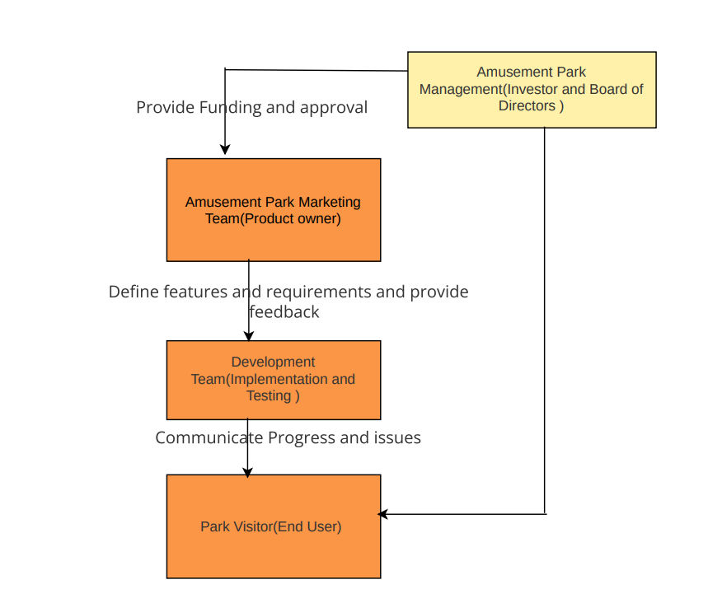

Figure 1: Shows Stakeholders Interaction

**System Requirements**

The Accessible Amusement Park Platform will be developed as a Web Application with the following technical characteristics.

* Programming Languages: JavaScript and PHP shall be used by the project.
* Front-End Technologies: The project shall use HTML and CSS for user interface development.
* Back-End Technologies: The project shall use PHP for server-side processing and as the language for data management.
* Browser Compatibility: The project shall support the current versions of major web browsers, and such requirements shall reflect the software design specification template.
* Accessibility: This platform shall ensure elements such as screen readers and navigation through the keyboard, among others.
* Responsive Design: The project shall, therefore, be compatible with various devices, including desktop, tablet, and mobile devices like smartphones.

These requirements ensure that the visage of the platform is efficient, convenient and compliant with the User’s needs.

**Feature Requirements**

|  |  |  |  |
| --- | --- | --- | --- |
| **No** | **User Story Name** | **Description** | **Release** |
| **1** | User Registration | The system shall enable users to register by inputting their details. This includes:   * Full name * Email address * Password   From the perspective of accessibility needs, users can set their preferences and change their registration information if necessary. The system will also guarantee that all input data is stored safely for future logins, and updating the system will be accessible. | **R1** |
| **2** | User Login | The system shall incorporate a login function to enable the users to log into the system using their credentials. This includes:   * Email address * Password   They will be allowed to do beneficial activities such as signing in securely, resetting passwords in cases where they have forgotten, or even seeking support. It will also have password recovery options and two-factor authentication in the event of generating stronger credentials. | **R2** |
| **3** | Accessible Navigation | The system shall ensure that all the site navigation elements are laid down to be made available. This includes:   * Screen reader compatibility * The browser navigation only by input with the keyboard * They should be easily identifiable and labelled on the webpage links for accessible locations. * The coherence of the structure of the right-hand side of the menu * All links, including About, Services, Accessibility Information, Contact Us, and Help, should be easily locatable.   These features are essential for consumers with disability to work through the platform in an orderly and expeditious manner. These features will consist of buttons and links' proper and obvious naming and availability of proper and easily reachable dropdowns. | **R3** |
| **4** | Park Amenities Information | The system shall cover most of the available park's facilities, including accessibility features. This includes:   * Information on ramps, elevators and barrier-free access entrances * Information on accessible restrooms and parking area * Facilities that are available for disabled guests   This guarantees that people with different abilities and disabilities are planning to visit the place and are well-prepared and informed on accessibility. | **R4** |
| **5** | Ride Information | The system shall display real-time information about park rides, including The system shall display real-time information about park rides, including:   * Ride availability * Each ride's appeal must accommodate people with disabilities. * Estimated wait times * Services for people with disabilities or people with disability special needs   It also makes it easier for visitors to plan for their visit and make some decisions on the rides they would wish to take. | **R5** |
| **6** | Booking and Reservations | The system shall allow users to schedule and make bookings and reservations on park rides and facilities. This includes:   * Selecting ride times * Indicating accessibility needs * Receiving booking confirmations * Monitoring and altering table bookings   These functionalities make the user experience more accessible regarding the booking process and planning. It will also be used to send out reservation reminders and ticket information. | **R6** |
| **7** | Time Management | The system shall offer various means to assist users in organizing their time at the premises. This includes:   * Planning their visit * Fixing rides and events * The calendar feature is quite effective in organizing lessons. * It is an ideal way of creating reminders for specific events.   These features assist in managing time well and also improve the visitor's experience. This will help to synchronize the system with a personal calendar and deliver notifications for upcoming events. | **R7** |
| **8** | User Profile Management | The system shall provide the users with the profiles to perform the following tasks.   * Observability and change of the information stored about the person * The management of the accessibility settings and the options that accompany it * Personal account: adding/editing/deleting individuals, modifying passwords.   The users will own the profiles and will be fully qualified to change the settings whenever they want. It will also accommodate profile picture uploads and configurations for privacy settings. | **R8** |
| **9** | Communication with Park Officials | For this reason, the system shall entail interfaces allowing users to link to the park authorities. This includes:   * Inquiry forms * Support request forms * Feedback submission * Decisions to include a document or an image   These features help users call the park officials and seek their assistance. It will also consist of live chatting services and track requests and responses in the system. | **R9** |
| **10** | Feedback and Support | The system shall provide means for reporting bugs, giving feedback and asking for Help. This includes:   * Some are feedback on how to be involved in such an activity. * Some of the recommendations focus on the questions of access. * Including extensive comments * This is mainly focused on monitoring the feedback that customers of the business are giving and the support tickets that individuals and companies are opening.   These features allow the User to provide the necessary details and ensure he or she will be provided with the correct Help at the right time. The following activities demonstrate that feedback will be addressed, and support requests will be filtered and prioritized as necessary. | **R10** |
| **11** | Multilingual Support | The system shall be able to work with different users and, therefore, be made multilingual. This includes:   * Language selection dropdown * Interpretations of the messages that circulate through all the major media outlets across the globe * Recognition of the languages which are employed in everyday practice as equal.   These features help develop the option for users with different language proficiency levels to use the platform most effectively. The system can translate content to users’ preferences and provide assistance and support in one or several languages. | **R11** |
| **12** | Responsive Design | It shall be easy to use and capable of running on various platforms and devices. This includes:   * Compatibility with office computers, tablets, and handheld mobile phones. * Responsive layouts * Ideal examples of place for images and number of text * Adaptive content | **R12** |
| **13** | Real-Time Notifications | The system shall be able to display fundamental alerts regarding availability for rides, booking requests and confirmations. | **R13** |
| **14** | Social Media Sharing | The system shall enable users to share their park experiences, such as ride bookings, feedback, etc., to social media platforms such as Facebook and Instagram. | **R14** |
| **15** | **Personalized Itinerary Planner** | It is possible to include preferences (e.g. types of rides, accessibility issues, time constraints), and the system will provide the best schedule for the user’s day, including when to catch a ride and when to rest. | **R15** |
| **16** | **Virtual Queue System** | Visitors can get in queues for the ride and wait their turn through notifications while enjoying other parts of the park. This makes visitors happy and reduces crowding around hot spots, leading to high satisfaction among the visitors. | **R16** |

### Non-Functional Requirements

**Performance**

* The homepage should fully load in under two seconds.
* Primary user interactions should have a response time of less than one second.

**Security**

* Data encryption for sensitive information
* User authentication and authorization
* Regular security updates and vulnerability assessments

**Scalability**

* Support for increasing the number of users and data volume
* Ability to handle peak usage times without degradation

**Usability**

* User-friendly interface with intuitive navigation
* Accessibility features for diverse user needs (e.g., screen reader compatibility, keyboard navigation)
* Clear instructions and feedback for user actions

**Reliability**

* The system should be available and operational 99.9% of the time.
* Backup and recovery procedures in place

**Compatibility**

* Support for major web browsers (e.g., Chrome, Firefox, Safari, Edge)
* Mobile and tablet responsive design.

**Maintainability**

* Modular codebase for more accessible updates and bug fixes
* Comprehensive documentation for system maintenance and future development

**Use case Diagram**

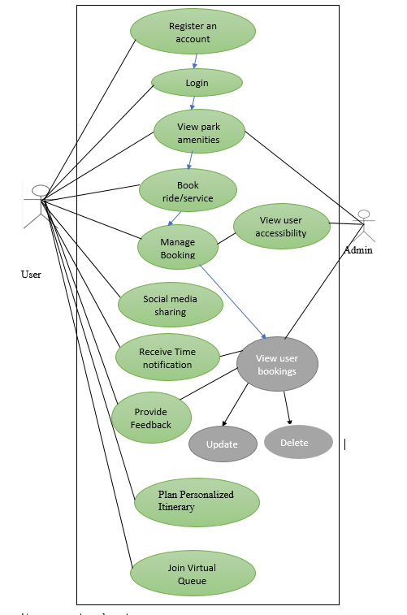

Figure 2: Use Case Diagram

User represents park visitor

Admin Represents Park Management

**Description of the Use case**

|  |  |
| --- | --- |
| **Use Case Number** | UC1 |
| **Use Case Name** | Registration of the user |
| **Overview** | This use case allows users to create a new account on the platform by providing their details and setting up a password. |
| **Actors** | Park Visitor (User) |
| **Pre-condition(s)** | The User visits the website's registration page. |
| **Scenario Flow** | Main success Flow  1. The User is taken to the registration page to complete the process.  2. The user enters full name, valid email address, and password of their preference when registering.  3. The User fills in the registration form. It checks the data entered and then generates a new account. |
| **Alternate Flow** | - If the email address is not unique, the system will display an error message to the User asking them to choose another email address.  -If the password entered is not valid according to the set security standards, the constraint message is displayed, and the User is redirected to the Password Options page, whereby a more secure password from several options is chosen. |
| Post Condition | A user account is created, and the User can log in with their new credentials. |

|  |  |
| --- | --- |
| **Use Case Number** | UC2 |
| **Use Case Name** | User Login |
| **Overview** | This use case lets users enter their details and credentials to sign into their specific accounts. |
| **Actors** | Park Visitor (User) |
| **Pre-condition(s)** | The User has an existing account and is on the login page. |
| **Scenario Flow** | 1. The User goes to the login page  2. The User inputs their email and password correctly.  3. The User submits the login form.  4. The system then checks the credentials and proceeds to the Log in the User   1. 5. The users are then taken back to his/her dashboard or home page. |
| **Alternate Flow** | If the entered email address or password is incorrect, the system will show an error message to the User and ask them to retype it.  If the User has forgotten the password, he can apply for a password reset. |
| **Post Conditions** | A user account is created, and the User can log in with their new credentials. |

|  |  |
| --- | --- |
| **Use Case Number** | UC3 |
| **Use Case Name** | View Park Information |
| **Overview** | This use case enables a user to get general information about every park; this includes the rides they have, services they offer and whether they are accessible or not. |
| **Actors** | Park Visitor (User), Park management (Admin) |
| **Pre-condition(s)** | The system allows user to login |
| **Scenario Flow** | -User navigates to the park information section.  -Customers obtain knowledge of the park’s rides and services and other facilities designed for disabled individuals.   1. -User information preferences may be configured by the type of ride available or by specific characteristics such as disabled access. |
| **Alternate Flow** | If the information is not found, a message will appear on the screen to notify you that the specific data is unavailable. |
| **Post Conditions** | The User has accessed and reviewed park information. |

|  |  |
| --- | --- |
| **Use Case Number** | UC4 |
| **Use Case Name** | Book Rides and Services |
| **Overview** | This use case allows users to reserve or schedule rides, services, or accommodations. |
| **Actors** | Park Visitor (User) |
| **Pre-condition(s)** | The User is logged into the system and has selected a ride or service. |
| **Scenario Flow** | 1. The User decides on a ride or service he intends to book. 2. The User selects a time slot of his/her convenience and gives information on possible barriers to access. 3. Booking summary: The User agrees with all the above information for the booking. 4. It also assigns a slot, the booking details are processed, and then a confirmation is given to the User. |
| **Alternate Flow** | In this case, the system alerts the User with a message asking him/her to input a different time of the day. |
| **Post Conditions** | The User gets a reservation confirmation, and the booking process is confirmed. |

|  |  |
| --- | --- |
| **Use Case Number** | UC5 |
| **Use Case Name** | Manage Bookings |
| **Overview** | This particular use case allows the user to check the existing bookings they have made and modify or even delete them. |
| **Actors** | Park Visitor (User),Park management(Admin) |
| **Pre-condition(s)** | The User is logged into the system and has existing bookings. |
| **Scenario Flow** | 1. The User enters into the section where his or her bookings are mentioned.  2. The User can view all the services he/she has booked.  3. The User selects one or many bookings that he/she wants to update or cancel.  4. The User comes in with changes he or she wishes to make or withdraw any booking that was made.  5. From the system, the customer is told that there has been a change on the booking and details of the change show that the booking has been altered. |
| **Alternate Flow** | The system provides an understandable message when the booking cannot be edited or cancelled because of some restrictions. |
| **Post Conditions** | Booking is updated or cancelled according to the User's request. |

|  |  |
| --- | --- |
| **Use Case Number** | UC6 |
| **Use Case Name** | Access Accessibility Information |
| **Overview** | This use case lets users view detailed accessibility information for each ride or service. |
| **Actors** | Park Visitor (User) |
| **Pre-condition(s)** | The User is logged into the system. |
| **Scenario Flow** | -A user selects a ride or service to which he or she wants to know its availability.  -Further data regarding the ride or service availability is available in the system. |
| **Alternate Flow** | If, for instance, there is no information on the availability of a given ride or service, the system will return a message stating that the information is unavailable. |
| **Post Conditions** | The User has accessed and reviewed accessibility information for a ride or service. |

|  |  |
| --- | --- |
| **Use Case Number** | UC7 |
| **Use Case Name** | Submit Feedback |
| **Overview** | This use case allows users to provide feedback about their experience with the platform, rides, or services. |
| **Actors** | Park Visitor (User) |
| **Pre-condition(s)** | The User is logged into the system. |
| **Scenario Flow** | 1. The User navigates to the feedback section. 2. User fills out a feedback form with their comments and ratings. 3. The User submits the feedback form. 4. The system records the feedback and confirms receipt. |
| **Alternate Flow** | If the feedback form needs to be completed, the system prompts the User to complete all required fields. |
| **Post Conditions** | Feedback is submitted and recorded in the system. |

|  |  |
| --- | --- |
| **Use Case Number** | UC8 |
| **Use Case Name** | Admin Login |
| **Overview** | This use case allows park administrators to log into the system with elevated permissions. |
| **Actors** | Park Management (Admin),User |
| **Pre-condition(s)** | Admin has valid credentials and is on the login page. |
| **Scenario Flow** | 1. Admin navigates to the admin login page. 2. Admin enters their username and password. 3. Admin submits the login form. 4. The system verifies credentials and logs the admin in. 5. Admin is redirected to the admin dashboard. |
| **Alternate Flow** | If credentials are incorrect, the system displays an error message and prompts the admin to try again. |
| **Post Conditions** | Admin is logged in and can access admin features. |

|  |  |
| --- | --- |
| **Use Case Number** | UC9 |
| **Use Case Name** | Manage Park Information (Admin) |
| **Overview** | This use case allows administrators to add, update, or remove park details. |
| **Actors** | Park Management (Admin),User |
| **Pre-condition(s)** | Admin is logged into the system. |
| **Scenario Flow** | 1. Admin navigates to the park information management section. 2. Admin selects an option to add, update, or remove park details. 3. Admin makes the necessary changes and submits them. 4. The system updates the park information and confirms the changes. |
| **Alternate Flow** | The system displays a relevant message if the update cannot be processed due to system constraints. |
| **Post Conditions** | Park information is updated or removed according to the admin’s request |

|  |  |
| --- | --- |
| **Use Case Number** | UC10 |
| **Use Case Name** | Generate Reports (Admin) |
| **Overview** | This use case allows administrators to generate usage and feedback reports for analysis. |
| **Actors** | Park Management (Admin) |
| **Pre-condition(s)** | Admin is logged into the system. |
| **Scenario Flow** | 1. Admin logs into the account and goes to the part of the product where the report generation is supposed to be situated. 2. The software admin chooses what sort of report they want to produce, whether a usage or feedback report. 3. Admin sets parameters for the report and then runs the report. 4. The system then produces the report, giving the user a link to download the report or showing the report on the screen. |
| **Alternate Flow** | The system will produce an error message if the report cannot be produced for any reason. |
| **Post Conditions** | The report is generated and available for review or download. |

|  |  |
| --- | --- |
| **Use Case Number** | UC11 |
| **Use Case Name** | Receive Real-Time Notifications |
| **Overview** | This use case enables the opponents to receive real-time notifications about the availability of rides for booking, ride confirmations or closure of a particular ride. |
| **Actors** | Park Visitor (User) |
| **Pre-condition(s)** | The User is logged into the system, and further notification settings are active. |
| **Scenario Flow** | 1. The user turns on the notification for the ride status and the bookings. 2. The system updates the availability or the status of the ride that has been booked. 3. All notifications are sent to the user in real time. 4. The user responds to the notifications (e.g., enters a ride, cancels, etc.). |
| **Alternate Flow** | If notifications are disabled, then no notification or update is made. |
| **Post Conditions** | Notifications are delivered with the help of pop-up notifications in the mobile application. |

|  |  |
| --- | --- |
| **Use Case Number** | UC12 |
| **Use Case Name** | Share to Social Media |
| **Overview** | This use case allows users to inform friends and families over social media platforms about their park experiences, such as booking a ride or giving feedback. |
| **Actors** | Park Visitor (User) |
| **Pre-condition(s)** | The User is logged into the system and linked to his/her Social Media platform. |
| **Scenario Flow** | The user chooses a ride or service to be shared on social media.  The system lets the user select from those social media sites supported in the application.  The system shares the desired information (e.g., ride details and feedback) on the user’s social media. |
| **Alternate Flow** | If social media is not linked, the system informs users that their account is not linked and asks if they want to link it. |
| **Post Conditions** | Sharing the post on the selected social media site is a success. |

|  |  |
| --- | --- |
| **Use Case Number** | UC13 |
| **Use Case Name** | Plan Personalized Itinerary |
| **Overview** | This use case assists the users in improving their timetable according to their desirability and disability status. |
| **Actors** | Park Visitor (User) |
| **Pre-condition(s)** | The User is logged into the system, so he has made the preferences concerning the system. |
| **Scenario Flow** | 1. The user enters preferences for the ride, such as accessibility needs, type of ride they desire, etc. 2. The system design produces an optimal schedule. 3. The user can also modify the itinerary depending on his/ her preference or the park schedule. 4. For instance, the system reminds the user of the next ride or event to attend. |
| **Alternate Flow** | In case a ride gets cancelled, there is always another one that the app recommends. |
| **Post Conditions** | This itinerary is produced for the user and used by him/her throughout the visit. |

|  |  |
| --- | --- |
| **Use Case Number** | UC14 |
| **Use Case Name** | Join Virtual Queue |
| **Overview** | This use case has been designed to enable people to form a virtual queue for the rides so they do not have to stand in physical lines. |
| **Actors** | Park Visitor (User) |
| **Pre-condition(s)** | The user is connected to the system while a virtual waiting list is also present. |
| **Scenario Flow** | 1. The user chooses a ride and enters a virtual queue from the system connected to the Internet. 2. It shows and notifies the user of the position of his/her queue number. 3. When it is almost this user’s turn to be served by the ride, he will be notified. 4. In this case, notification leads the user to the ride, thus resulting in minimal physical waiting times. |
| **Alternate Flow** | The system can choose another time to order the food if the queue is complete. |
| **Post Conditions** | Organizations create an environment for users to enter a virtual line to wait for the ride and be informed when it is their turn. |

**Individual Contributions**

|  |  |  |
| --- | --- | --- |
| **Team Member Name** | **8-Digit Student ID** | **Task Description** |
|  |  |  |
|  |  |  |
|  |  |  |
|  |  |  |